**SEQUENCE DIAGRAMS**

* **ACCESS AND SECURITY**

1. The manager initiates a request to view the analytics page.
2. The analytics page sends a request to the authentication server to authenticate the manager.
3. The authentication server prompts the manager for their username and password.
4. The manager submits their username and password to the authentication server.
5. The authentication server verifies the submitted credentials.
6. If required, the authentication server prompts the manager for multi-factor authentication.
7. The manager confirms the multi-factor authentication.
8. The authentication server verifies the multi-factor authentication.
9. Once authentication and authorization are successful, the authentication server notifies the analytics page.
10. The analytics page grants access to the manager and displays the analytics.

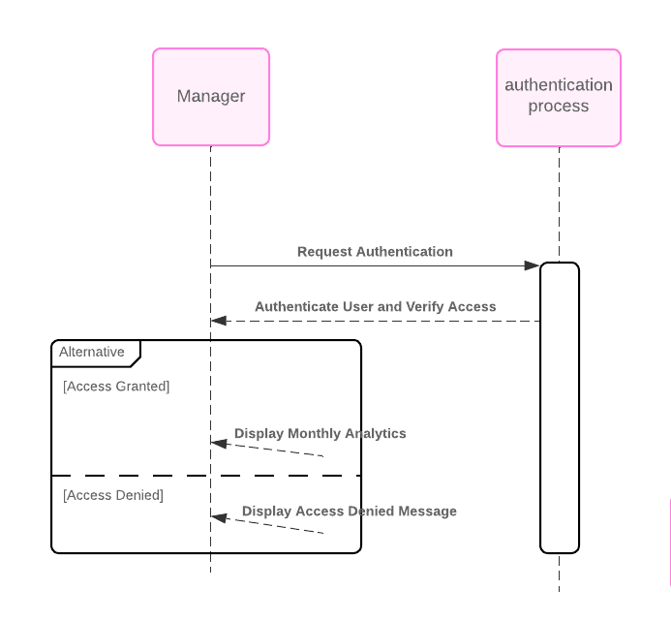

* **Mobile Compatibility**

1. The manager opens the analytics app on their mobile device.
2. The mobile device sends a request to the analytics page for the analytics page.
3. The analytics page responds by sending the mobile-compatible version of the analytics page to the mobile device.
4. The mobile device receives the mobile-compatible analytics page.
5. The mobile device displays the analytics on its screen for the manager to view.

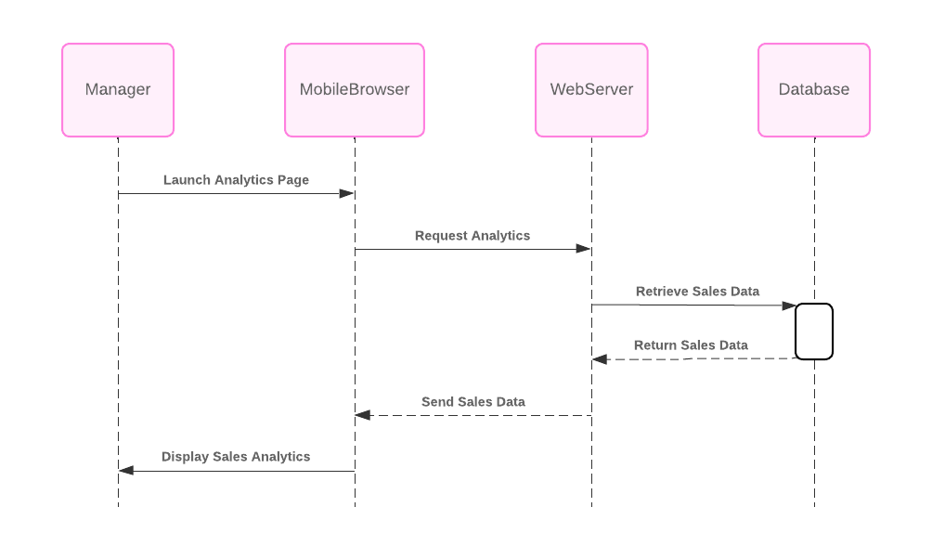

* **Dashboard including Visual Display**

1. The manager initiates a request to view the specialized dashboard.
2. The dashboard system sends a request to the backend system to retrieve the monthly analytics data, including total sales, top-selling automobiles, and other relevant data.
3. The backend system responds by sending the monthly analytics data to the dashboard system.
4. The dashboard system processes the received data and generates visual representations such as graphs, charts, or other graphical displays.
5. Finally, the dashboard system sends the specialized dashboard with visual representations back to the manager for viewing.

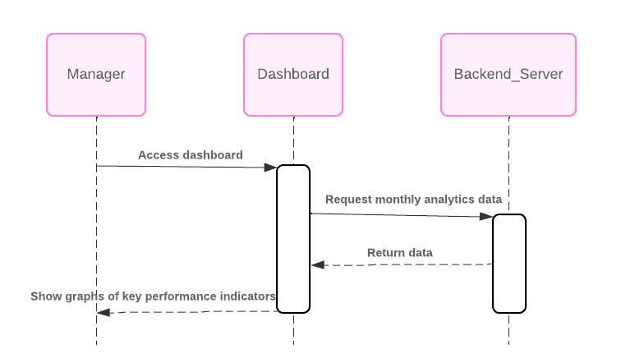

* Real-Time Data Updates

1. The manager initiates a request to view the monthly analytics.
2. The analytics page sends a request to the backend system to retrieve real-time analytics data.
3. The backend system responds by sending the real-time analytics data to the analytics page.
4. The analytics page receives the real-time analytics data from the backend system.
5. Finally, the analytics page displays the real-time analytics data to the manager for viewing.

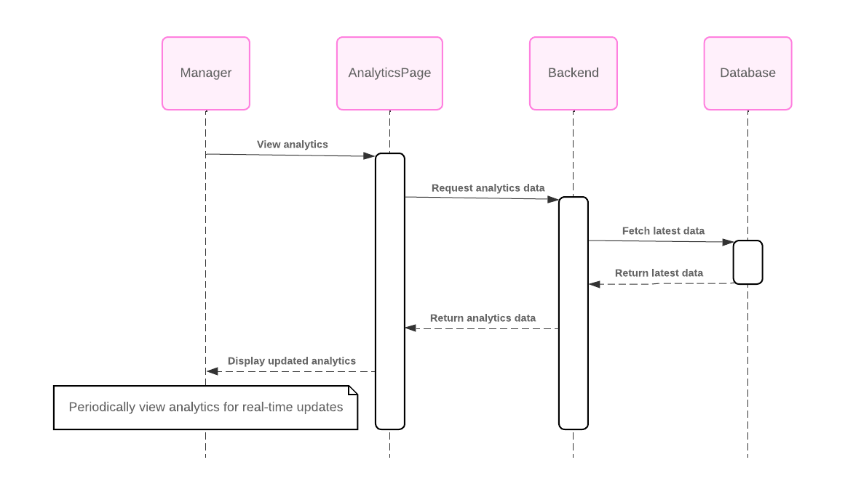

* Filtering and Sorting Options

1. he manager initiates a request to view the dashboard with filtering and sorting options.
2. The dashboard system sends a request to the backend system to retrieve the monthly analytics data.
3. The backend system responds by sending the monthly analytics data to the dashboard system.
4. The dashboard system applies the specified filtering and sorting options to the received data.
5. Finally, the dashboard system sends the dashboard with filtered and sorted data back to the manager for viewing.

